Sustainable Minerals Institute  Sir James Foots Building (#47A)  St Lucia, Qld 4072 Australia  Email: jkpublications@uq.edu.au |  |  |  |  |  | 
MONOGRAPH ORDER FORM
Please complete this form by inserting data in the “field” prompts.
Return the completed form by email.
Please indicate the type of shipping address: Y / N - Residential Y / N - Business
Name: |  |  |  |  |  | Company:
Position: |  |  |  |  |  | Email:
Delivery Address:
 |  |  |  |  |  |  |  | Postcode/Zip:
Phone:
“An Introduction to Metal Balancing and Reconciliation”
Edited by: R D Morrison (Ed)

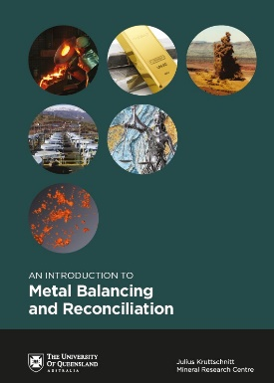 |  |  | AUD $250* |  |  |  |  |  |  | No. of copies required
* Cost excludes shipping, handling and taxes.
* Discount of 10% is available for orders of 10 or more books.

PAYMENT
On receipt of your order, we will obtain a quote for the freight via Australia Post for domestic orders, or courier for international orders. We will then send you an email advising the total amount payable to The University of Queensland with a secure paylink for payment via credit card. Once payment is received, your order will be dispatched.

