40 Isles Road
Indooroopilly, Queensland 4068 Australia
Facsimile: + 07 3365 5999
Int’l Fax: + 61 7 3365 5999
Email: jkpublications@uq.edu.au

JKMRC MONOGRAPH ORDER FORM
This form may be completed on your computer by inserting data at the “field” prompts, and then saved. The completed form may be returned by Email, Fax or Post.
ADDRESS FOR DELIVERY:
Name: |  |  |  |  |  | Company:
Position: |  |  |  |  |  | Email:
Delivery Address:
 |  |  |  |  |  |  |  | Postcode/Zip:
Phone: |  |  |  |  | Fax:
“GUIDELINES ON CAVING MINING METHODS”
THE UNDERLYING CONCEPTS

DENNIS LAUBSCHER, ALAN GUEST, JAREK JAKUBEC
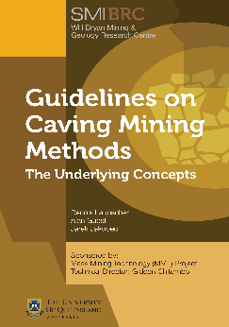 |  |  | AUD $250* |  |  |  |  |  |  | Copies required
* Cost excludes freight and taxes.
* A discount of 10% is available for orders of 10 or more books.
* Staff and Students of SMI may receive a discount of 20% (one copy per person). Students are required to provide proof of University enrolment with their Order Form.
CONFIRMING YOUR ORDER, AND PAYMENT:
On receipt of your order, we will obtain a quotation for the freight via courier, and an email will be sent to you advising the total amount payable to JKMRC (The University of Queensland). Payment may be made on the UQ secure online payment site, and a link to the payment site together with an explanation of the procedure will be provided. Once payment is received, your order will be dispatched and the Waybill number advised for tracking.

