   |  |  |  |  |  | 40 Isles Road  Indooroopilly, Queensland 4068 Australia  Facsimile: (07) 3365 5999  Int’l Fax: + 61 7 3365 5999  Email: jkpublications@uq.edu.au
MONOGRAPH ORDER FORM
This Form may be completed on your computer by inserting data at the “field” prompts, and then saved. The completed Form may be returned by Email, Fax or Post.
ADDRESS FOR DELIVERY:
Name: |  |  |  |  |  | Company:
Position: |  |  |  |  |  | Email:
Physical Address:
 |  |  |  |  |  |  |  | Postcode/Zip:
Phone: |  |  |  |  | Fax:
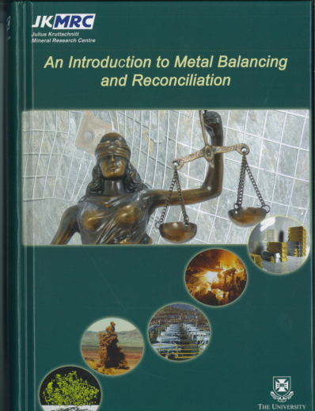 |  |  |  | “Metal Balancing and Reconciliation” |  |  |  |  |  | *AUD$ 220 |  | Copies required
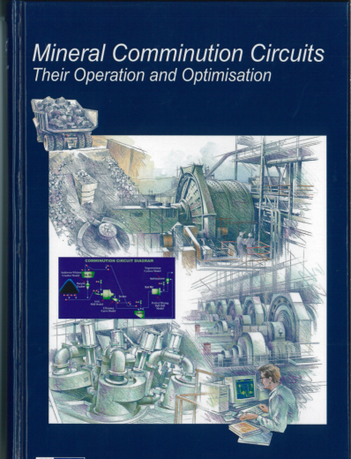 |  |  |  | “Mineral Comminution Circuits” |  |  |  |  |  | *AUD$ 200 |  | Copies required
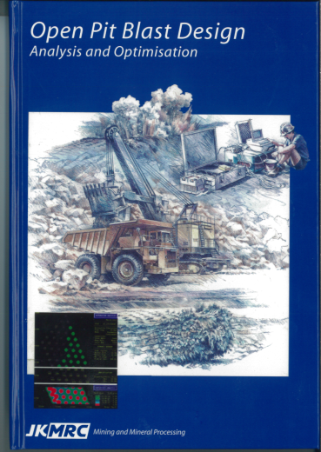 |  |  |  | “Open Pit Blast Design” |  |  |  |  |  | *AUD$ 200 |  | Copies required
* Cost excludes freight and taxes
* A 10% discount is available for orders of 10 or more books
* Staff and Students of SMI may receive a discount of 20% (one copy per person). Students are required to provide proof of University enrolment with their Order Form.
CONFIRMING YOUR ORDER, AND PAYMENT:
On receipt of your order, we will obtain a quotation for the freight via courier, and an email will be sent advising the total amount payable to JKMRC (The University of Queensland). Payment may be made on the UQ secure online payment site, and a link to the payment site together with an explanation of the procedure will be provided. Once payment is receipted, your order will be dispatched and the Waybill number advised for tracking.

